Jack Berberian

CIS 245

1/31/2022

Continue Setup Assignment for Ubuntu

Some things to know beforehand:

Sudo – is an important command which gives a user administrative or root access, which is necessary for some actions such as program installations.

Apt – is a package manager or a ‘store’ where programs can be found on Ubuntu (a version of Linux)

Install – needed to tell apt to install what you want to install

-y – can be used to skip prompts to confirm yes beforehand.

1. How to Install tmux

With tmux, you can use multiple terminal windows in one window.

Enter:

**Sudo apt install tmux -y**

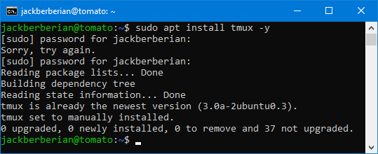

* To see if it ran successfully enter just tmux into the commandline:
  + Text

    Description automatically generated

1. How to Install emacs

To install emacs,

enter: **sudo apt install emacs -y**

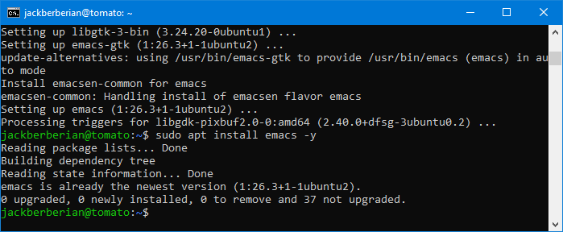

To see if emacs installed correctly, enter just emacs into the commandline:

* emacs
* A screenshot of a computer

  Description automatically generated with medium confidence

1. How to install fail2ban (Make sure you look through the fail2ban settings are you do the install)

* To install fail2ban, enter: **sudo apt install fail2ban - y**
* 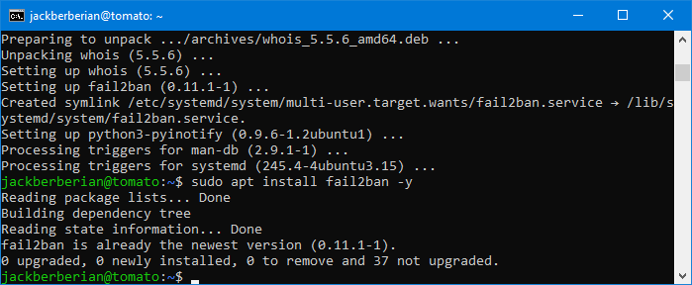
* The program automatically starts but enter this to check the status:
  + Sudo systemctl status fail2ban
  + Text

    Description automatically generated
* Allow SSH through the firewall and the firewall as well.
  + Enter: sudo ufw allow ssh
  + Enter: sudo ufw enable
    - Press enter when prompted.
    - Text

      Description automatically generated
* Copy the jail.conf file to /etc/fail2ban/jail.local
  + Enter: sudo cp /etc/fail2ban/jail.conf /etc/fail2ban/jail.local
    - in order to start configuring the settings.
* By opening the /etc/fail2ban/jail.local file in your text editor, you can change the settings for fail2ban.
  + Enter:
    - Sudo nano /etc/fail2ban/jail.local
  + For example: you can add your IP address that you’ll use to login into the server as ignoreip = (your ipaddress) so you don’t get locked out.
  + A screenshot of a computer

    Description automatically generated with medium confidence
  + A screenshot of a computer

    Description automatically generated with medium confidence
  + You can leave these default commands alone.
  + If you made any changes to the /etc/fail2ban/jail.local file other than adding your IP address of your computer to ignoreip = yourip, press CTRL+x, enter then save.
  + Enter this to restart fail2ban
    - Service fail2ban restart
    - Text

      Description automatically generated
  + To see if you were successful, enter:
    - sudo systemctl status fail2ban
    - Text

      Description automatically generated

1. Install cowsay

To install cowsay, enter: **sudo apt install cowsay -y**

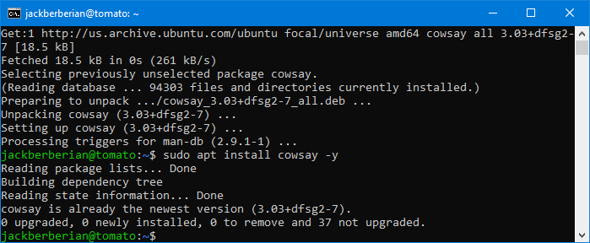

To see if it installed correctly, enter:

* cowsay hello-world

1. Install lolcat

To install lolcat, enter: **sudo apt install lolcat -y**

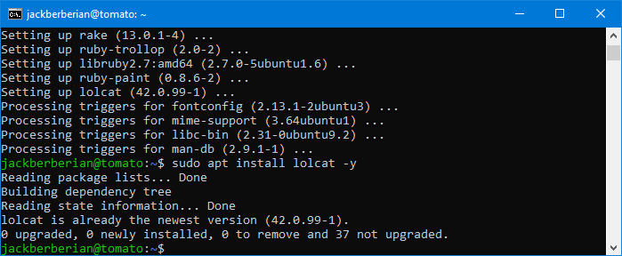

To see if it installed correctly, enter any text and then pipe it to lolcat

In this case I entered: hostname | lolcat

* Text

  Description automatically generated

1. Update VI to vim

To update VI to vim, you can enter: **sudo apt get update** and then **sudo apt install** which will first update all programs on the system and the select the latest version of vim to install.

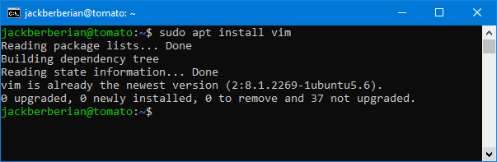

To see if VIM installed correctly, just enter:

* Vim
* A screenshot of a computer

  Description automatically generated

1. Update your servers if it’s needed

To update your servers, you can try the command

**Sudo apt update**

And then

**Sudo apt upgrade**

Which will look for updates on the server and then upgrade will install them.

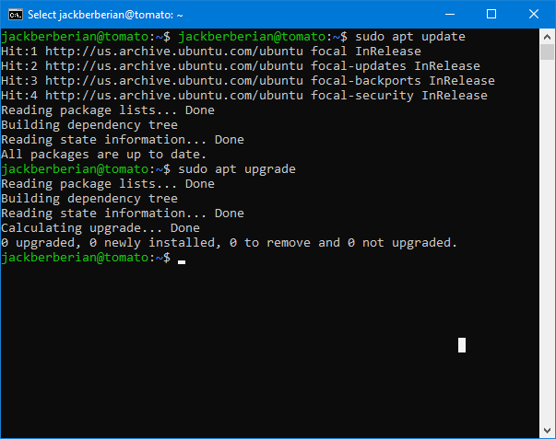

If you have something to update and upgrade, it’ll prompt you to accept but otherwise, it’ll say this:

1. Another way to access file shares on Ubuntu
   1. Download and install WinSCP from <https://winscp.net/eng/docs/guide_install>
   2. Launch WinSCP and enter details for your system.

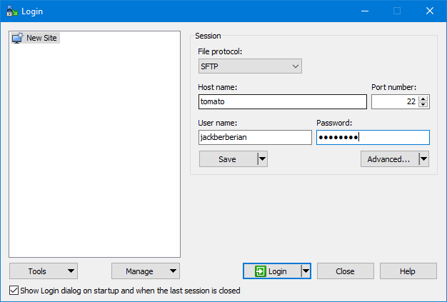

* 1. Press yes when prompted.

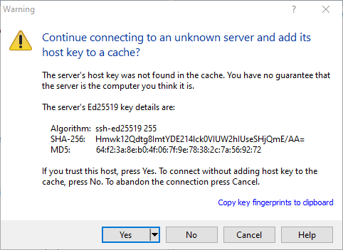

* 1. Now, you can select and transfer any files.

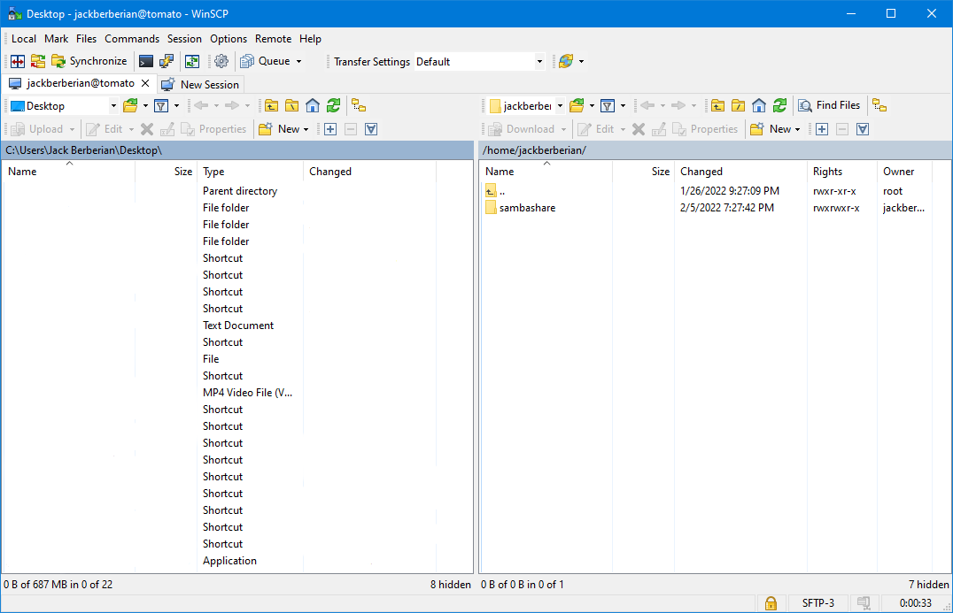

Where the Repo’s Live, How I can Find them, How to Add/Modify a Repo or PPA.

Where the Repos Live and How to Find Them

In Ubuntu, software repositories live at the file located at /etc/apt/sources.list

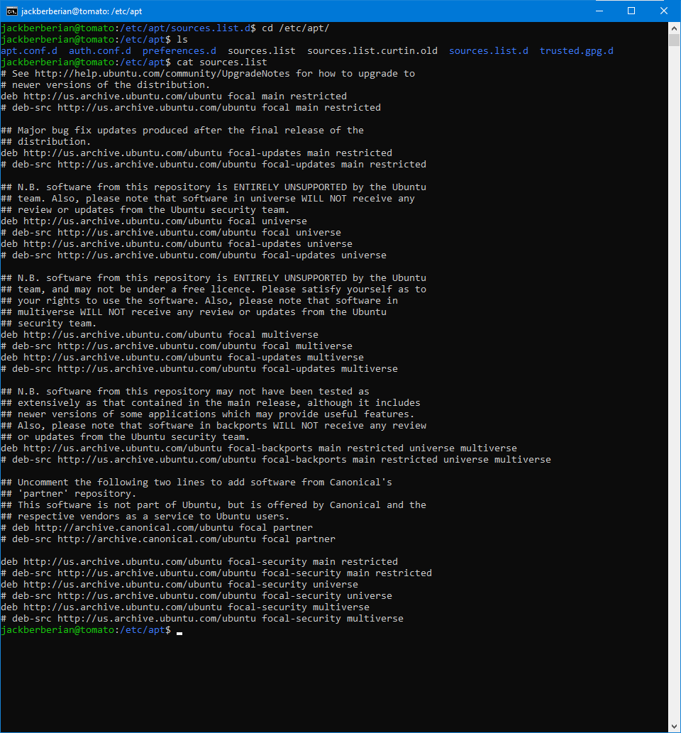

How to Add/Modify a Repo or PPA

1. To remove software, enter: **sudo apt remove (name of program to remove)**

Where my repos live, how can I find them, and how do I add/modify a repo or PPA.

In order to find your repos or repositories on Ubuntu, you can just enter apt list –installed and it’ll list everything that you have installed. Here’s a screenshot below of a small sample of what I have.

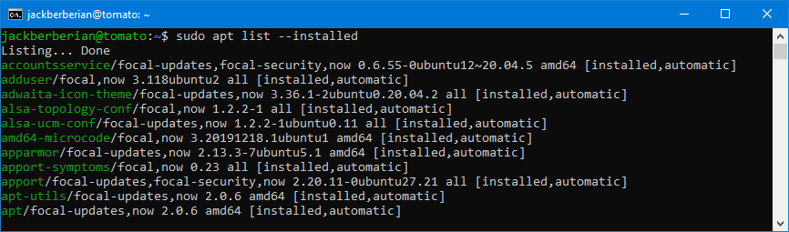

How to Add or Modify a Repo

* One of the ways that you can add a repo is that after a package is installed, you can tell it to remove something like **sudo apt get purge fail2ban**

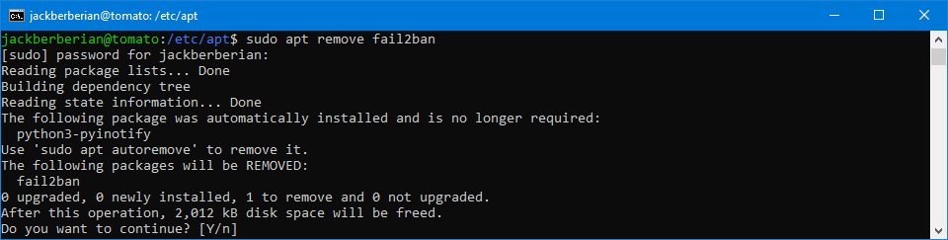

Citations:

<https://www.a2hosting.com/kb/security/hardening-a-server-with-fail2ban>

<https://www.linode.com/docs/guides/using-fail2ban-to-secure-your-server-a-tutorial/>

<https://access.redhat.com/documentation/en-us/red_hat_enterprise_linux/6/html/deployment_guide/sec-managing_yum_repositories>